## Question 1

### Disease 1 - Very Dangerous Disease

|  |  |  |
| --- | --- | --- |
| (a) | Period Prevalence (jan 1 - Dec 31) | $\frac{ \# cases during Jan 1 - Dec 31 }{ \# indv in the pop Jan 1 - Dec 31 }=\frac{4}{ 7 }≈5.7$ per 10 persons |
| (b) | Point Prevalence (July 15) | $\frac{ \# cases in the pop on July 15 }{ \# indv in the pop July 15 }=\frac{3}{ 5 } ≈6$ per 10 persons |
| (c) | Cumulative Incidence (Jan 1 - Dec 31) | $\frac{ \# new cases during Jan 1 - Dec 31 }{\# indv at risk on Jan 1}=\frac{4}{ 5 }≈$ 8 per 10 persons |
| (d) | Incidence Density (Jan 1 - Dec 31) | $\frac{ \# new cases during Jan 1 - Dec 31 }{ Total person-years at risk Jan 1 - Dec 31 }=\frac{ 4 }{ 1+(6+6+8+4)/12 }≈$ 1333 per 1000 person-years |
| (e) | Crude Death Rate | $\frac{ Number of deaths during the year }{Mid-Year population size}=\frac{ 3 }{5}≈6$ per 10 persons |

### Disease 2 - Rapidly Fatal Disease

|  |  |  |
| --- | --- | --- |
| (a) | Period Prevalence (jan 1 - Dec 31) | $\frac{ \# cases during Jan 1 - Dec 31 }{ \# indv in the pop Jan 1 - Dec 31 }=\frac{3}{ 7 }≈$ 4.29 per 10 persons |
| (b) | Point Prevalence (July 15) | $\frac{ \# cases in the pop on July 15 }{ \# indv in the pop July 15 }=\frac{0}{ 4 } ≈$ 0 per 10 persons |
| (c) | Cumulative Incidence (Jan 1 - Dec 31) | $\frac{ \# new cases during Jan 1 - Dec 31 }{\# indv at risk on Jan 1}=\frac{3}{ 7 }≈4.29$ per 10 persons |
| (d) | Incidence Density (Jan 1 - Dec 31) | $\frac{ \# new cases during Jan 1 - Dec 31 }{ Total person-years at risk Jan 1 - Dec 31 }=\frac{ 3 }{ 4+(5+1+2)/12 }≈$ 642 per 1000 person-years |
| (e) | Crude Death Rate | $\frac{ Number of deaths during the year }{Mid-Year population size}=\frac{ 3 }{4}≈$ 75 per 100 persons |

## Question 2:

### **Compare the population stratum distributions of the men versus the women in Ontario.**

In the 18-34 stratum with a male population of ~1.59 million that is only slightly larger than the female population of ~1.5 million diabetes affects males at almost a 2 times rate as it does females at 32100 cases vs 16600 cases respectively.

In the 35-49 stratum with a male pop of roughly 1.38 million vs the female pop of roughly 1.43 million men have a slightly higher number of cases of diabetes at 62500 vs 61300 for women of the same age group.

Men in the 50-64 age group have a population of roughly 1.48 million while women of the same stratum have a population size of roughly 1.52 million where there are 170200 cases for women of this stratum and 223100 of men in this stratum which is a difference of roughly 53000 for a population difference of only ~40000.

Men of the 65+ age stratum have a population size of 1136265 while women of this age group have a population of 1373033, men account for 279900 of the diabetes population of this stratum while women account for 233600 of this stratums diabetes population.

Overall at first glance men at all age stratums seem to be afflicted with diabetes at a higher rate than women of the same age groups.

### **Calculate the stratum-specific and overall prevalence rates for the men and women.**

prevalence rate (18-34)

Males $= \frac{ Number of diseased individuals in the stratum during the year }{Mid-year stratum population size}=\frac{ 32100 }{1588773}×10000≈$ 202.04 per 10000 persons

Females $= \frac{ \# of indv affected by disease in stratum }{population of stratum}=\frac{ 16600 }{1499360}×10000≈$ 110.7 per 10000 persons

Stratum Specific Prevalence Rates Table

|  |  |  |
| --- | --- | --- |
| Stratum | Females (per 10000) | Males (per 10000) |
| 18-34 | 110.7139046 | 202.0427084 |
| 35-49 | 426.1232309 | 453.0771551 |
| 50-64 | 1120.283717 | 1508.094771 |
| >=65 | 1701.342939 | 2463.333817 |

Overall Prevalence Rate Table

|  |  |  |
| --- | --- | --- |
| stratum | Female (per 10000) | Male (per 10000) |
| all | 826.2149408 | 1070.230472 |

### Use Direct Standardization to compute the Directly Adjusted Rates (DAR) for the men and women using the given national reference population.

We define the following notation for stratums j=1,2,...,J

|  |  |  |
| --- | --- | --- |
|  | Study Pop |  |
|  | i = 1, 2 | Ref Pop |
| Number of individuals afflicted with diabetes | $d_{ij}$ | $D_{j}$ |
| Stratum Size | $n_{ij}$ | $N_{j}$ |
| Stratum Specific Rates | $r_{ij}$ | $R_{j}$ |

Using the following formula to calculate the expected number of people afflicted with diabetes. Note that $r_{ij}$ was calculated above. The calculation for stratum i=1 (females) is shown below:

${E^{D}}_{ij}=r_{ij}N_{j}$

${E^{D}}_{11}=r_{11}N_{1}=\frac{110.7139046}{10000}×7706705=85323.9402$

${E^{D}}_{12}=r_{12}N_{2}=\frac{426.1232309}{10000}×7401067=315376.6582$

${E^{D}}_{13}=r_{13}N_{3}=\frac{1120.283717}{10000}×7769520=870406.6748$

${E^{D}}_{14}=r_{14}N_{4}=\frac{1701.342939}{10000}×6595070=1122047.578$

Then we calculate a new number of individuals diseased rate in the reference population using the calculated expected values.

$DAR (pop i=1)=DAR_{1}=\frac{\sum_{j}{}{E^{D}}_{ij}}{\sum_{j}{}N_{j}}=8119.9968$ per 100,000

$DAR (pop i=2)=DAR_{2}=11154.0$ per 100,000

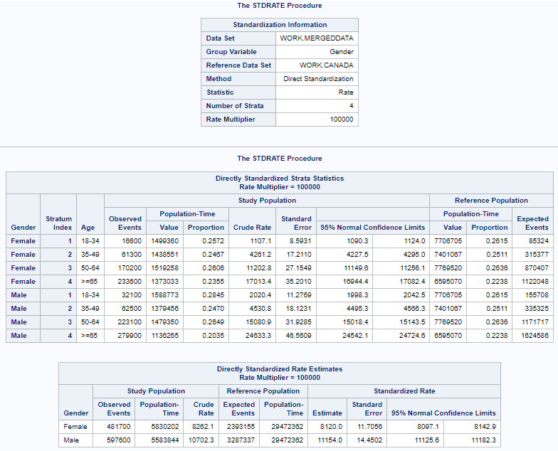

### Use the reference population rates and Indirect Standardization to compute Standardized Prevalence Ratios (SPR) and Indirectly Adjusted Rates (IAR) for the men and women.

Using the following formula to calculate the standard mortality ratio as well as the Indirect adjusted rate. Note that we are interested in people who have diabetes instead of how many deaths have occured. The calculation for stratum i=1 (females) is shown below:

$SPR_{i}=\frac{ Observed Diseased Individuals }{Expected Diseased Individuals}=\sum_{j}{}\frac{d_{ij}}{R_{j}n_{ij}}=\sum_{j}{}\frac{r_{ij}n_{ij}}{R_{j}n_{ij}}$

$R_{1}=\frac{93200}{7706705}, R_{2}=\frac{ 323200 }{7401067}, R_{3}=\frac{845400}{7769520}, R_{4}=\frac{1217900}{6595070}$

$SPR_{1}=\sum_{j}^{4}{}\frac{d_{1j}}{R_{j}n_{1j}}=\frac{16600 + 61300 + 170200 + 233600}{\frac{93200}{7706705}×1499360 + \frac{ 323200 }{7401067}×1438551 + \frac{845400}{7769520}×1519258 + \frac{1217900}{6595070}×1373033}$

$SPR_{1}=0.96375$

$SPR_{2}=1.3273$

The SAS output is shown below

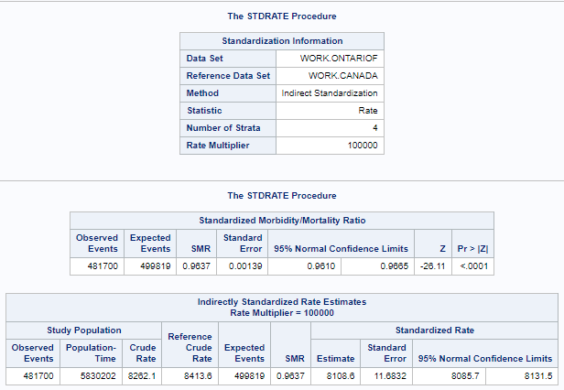

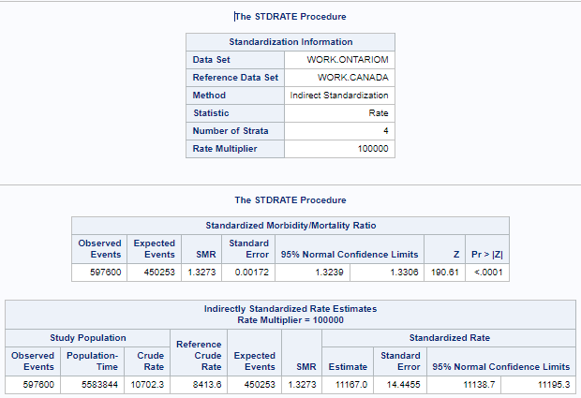

Then we calculate the IAR of the respective populations. We are using SPR instead of SMR in this case.

$IAR (pop i=1)=\frac{\sum_{j}{}{E^{D}}_{ij}}{\sum_{j}{}N_{j}}=SMR_{i}×(CDR in Ref pop)=\frac{\sum_{j}{}d_{ij}D_{j}}{\sum_{j}{}R_{j}n_{ij}}\frac{\sum{}D_{j}}{\sum{}N_{j}}$

$(CDR in Ref pop)=\frac{ \# individuals with diabetes in ref pop }{total population in ref pop}=\frac{93200+323200+845400+1217900}{7706705+7401067+7769520+6595070 }=0.084136$

$IAR (i =1)=0.96375×0.084136=8108.607$ per 100,000 persons

$IAR (i =2)=1.3273×0.084136=11167.371$ per 100,000 persons

### Provide a few sentences comparing the diabetes prevalence of the men and women of Ontario in 2019. Make specific reference to which measures (i.e. DAR, SPR, IAR) you are using in your comparison(s).

The DAR for Males in Ontario is roughly 11,154 per 100,000 which is higher than the crude rate of the reference population at 10,702 per 100,000 people because males in the age range 18-34 and 50-64 have a much higher proportion of people who have diabetes compared to the reference population. Where the reference population has roughly 3 times as many incidences of diabetes compared to the Ontario males of the 18-34 age range with only 5 times the population meaning there is a disproportionately high number of incidences in the male Ontarian population. Meanwhile the female DAR is roughly 8,120 per 100,000 compared to the crude rate of the reference population at 8,413 per 100,000. Overall the DAR suggest that women have a lower incidence of having diabetes compared to men who have a higher incidence.

The SPR value calculated for the male study/Ontario population of 1.3273 means that there is a roughly 32.7% higher prevalence of diabetes in men than the expected value meanwhile the female population’s SPR value was calculated at 0.96375 meaning that females in the study population are 3.3% under the expected prevalence rate where the reference population is Canada’s population.

The male study population's IAR of 11,167.371 per 100,000 compared to the crude rate for men of 10,702 per 100,000 means that after standardizing for age the rate of men with diabetes is higher than the crude rate. For women the crude rate is 8,262.1 per 100,000 persons compared to the lower IAR of 8,108.6 per 100,000 which is lower than the crude rate. This data also shows that women have a lower incidence of diabetes while men have a higher incidence.

## Question 3:

### For each study described below, determine the risk factor(s) or exposure(s) under study, the outcome(s) under study, and indicate what medical study design is being described.

|  |  |
| --- | --- |
| Study (a) | |
| Risk factor(s) or Exposure(s) | Whether or not a male individual has had a stroke |
| outcome(s) | Males who have suffered from a stroke have higher incidences of diabetes, hypertension, and were less physically active compared to men who have not suffered from a stroke. |
| Medical study design type | Case-Control Study |

### 

|  |  |
| --- | --- |
| Study (b) | |
| Risk factor(s) or Exposure(s) | Older adults who with subjective memory complaints |
| outcome(s) | The study population who were in the integrated psychostimulation program and computerized cognitive training reported a decrease in anxiety symptoms |
| Medical study design type | Case Study |

### 

|  |  |
| --- | --- |
| Study (c) | |
| Risk factor(s) or Exposure(s) | Whether or not food allergies and respiratory allergies are associated with a prevalence of ADHD. |
| outcome(s) | The questionnaire analysis showed that having a food allergy was associated with an increased prevalence of ADHD. |
| Medical study design type | Cross-Sectional study |

### 

|  |  |
| --- | --- |
| Study (d) | |
| Risk factor(s) or Exposure(s) | If there is a correlation between tobacco control policies and tobacco consumption in 27 countries of the European Union. |
| outcome(s) | Analysis showed that the level of smoke-free legislation was correlated with a decrease in the prevalence of smoking and showed an increase in the intent to quit smoking within the past 12 months |
| Medical study design type | Ecological Study |

### 

|  |  |
| --- | --- |
| Study (e) | |
| Risk factor(s) or Exposure(s) | Whether or not there is a correlation between diet type and incidence of gout in men in the study population. |
| outcome(s) | A higher DASH dietary pattern score was associated with a lower risk for gout while a higher Western dietary pattern score was associated with an increased risk for gout. |
| Medical study design type | Cohort Study |

## Question 4:

The scientific research question the authors attempted to address in this study was standardizing the tooth wear findings from earlier reports and studies as well as finding exposures for tooth wear.

An important exposure of interest in this study was tooth brushing because it is closely related to both NCCL (non‐carious cervical lesion), as well as retraction of the gingival margin which was included as an exposure as well. Two studies conducted with two different county’s (Skane in 2007-08 and Kalmar in 2011-2012) of southern Sweden were conducted using a questionnaires sent to citizens known to be living in the respective counties at the time and also randomly chosen by the Swedish Population Address Register with citizens who have moved, an unknown address or are deceased removed.

The primary outcomes of these studies were determined from the new index of standardized tooth wear, the Basic Erosive Wear Examination. Out of the BEWE group of size 671 around 3.3% scored no risk, 49.6% scored low risk, 42.5% scored medium risk and 4.6 scored high risk on the scale. In the BEWE-adjusted group consisting of 106 people 25.5% registered low risk, 52.8% scored medium risk and 21.7% scored in the high risk category.

The outcomes of the study in Skane were obtained by a follow-up dental examination at either the Faculty of Odontology at Malmo University in Sweden as well as 3 clinics of Public Dental Health Service during March 2007 to November 2008. 90.5% of the examinations were conducted by 4 dentists while the remaining 9.5% were conducted by 4 other dentists. The examinations proceeded using standard examination procedures where the dentists were coordinated regarding the diagnostic criteria which was explained in written instruction, practice and discussion of clinical cases. In Kalmar 2000 questionnaires were sent and out of those 900 individuals were offered a dental examination where only 380 accepted the examination. These examinations were performed during April 2011 through July 2012. Two dentists performed all of the examinations in 4 public dental clinics using the same variables as those used in Skane.

|  |  |  |  |  |
| --- | --- | --- | --- | --- |
| Table 4: Frequency table of Tooth wear status vs. Exposure to acidic drinks | | | | |
|  | Not Diseased (No or low risk) | Diseased (Medium or High risk) | sum | outcome prevalence |
| Exposed (Daily intake of acidic drinks) | 90 | 77 | 167 | 46.107% |
| Unexposed (Almost never) | 265 | 239 | 504 | 47.420% |
| sum | 355 | 316 | 671 |  |
| exposure prevalence | 25.352% | 24.367% |  |  |

The outcome prevalence of both groups that did and did not drink acidic drinks daily had similar values around 47% and 46% respectively meaning that there is a slightly increased prevalence in the unexposed group. The results of the study also concluded that the relation between tooth wear and the exposed group was insignificant.

To run a cohort study to see the effect of daily intake of acidic drinks on tooth wear ideally a study population in a region of southern Sweden with people randomly chosen by the Swedish Population Address Register who also do not drink acidic drinks daily would be asked to allow for dental examinations, then prospectively the study population would be followed up with questionnaires especially regarding the exposures (i.e. intake of acidic drinks) as well as follow up dental examinations.

## Question 5:

|  |  |  |  |  |
| --- | --- | --- | --- | --- |
| Table 5: Incidence of Thyroid Cancer by smoking status | | | | |
|  | Not Diseased | Diseased | sum | |
| Exposed (ever or current smoker) | 40866 | 272 | 41138 | |
| Unexposed (Never smoked) | 54739 | 978 | 55717 | |
| sum | 95605 | 1250 | 96855 | |
| P(D+|E+) | 272 / 41138 = 0.00661189168 | |  | |
| P(D+|E-) | 978 / 55717 = 0.017552991 | |
| Relative Risk | 0.376681768 | |
| Risk Difference | -0.0109410993 | |  | |

1. Since the Relative Risk is lower than 1 it means that risk in the exposed is less than in the unexposed and could possibly mean a negative association. A relative risk of ~0.377 means that the study population is 0.377 times as likely to have thyroid cancer if they are smokers.

An additional ~ -1.094 cases of disease per 100 persons were observed in the exposed group versus the unexposed group or in other words ~1.094 cases of disease per 100 persons were observed in the unexposed (non-smoker) group versus the exposed (smoker / previous smoker) group

|  |  |
| --- | --- |
| Preventative fraction | $(1-\hat{ RR})×100\% =62.233\%$ |

1. This means that there is ~62.2% of thyroid cancer reduction in the exposed group that can be attributed to smoking.
2. The assumption of no association under $H_{0}$ means that $P[E+]$ is independent from $P[D+]$ i.e. $π_{12}=P[E+ and D+]=P[E+]×P[D+]=\frac{a+b}{n}\frac{b+d}{n}$ $0.42473801×0.0129058902=0.00548162212$ now we find the expected value under $H_{0}$.

$E_{ij}=\frac{ (row total)(column total) }{(sample size)}$

|  |  |  |  |
| --- | --- | --- | --- |
| Expected Values under $H_{0}$ | | | |
|  | D- | D+ |  |
| E+ | 40607.0774 | 530.922513 | 41138 |
| E- | 54997.9225 | 719.07748 | 55717 |
|  | 95605 | 1250 | 96855 |

|  |  |  |
| --- | --- | --- |
| Residuals | | |
|  | D- | D+ |
| E+ | 258.922513 | -258.922513 |
| E- | -258.922513 | 258.922513 |

$c^{*}=\sum_{i=1}^{2}{}\sum_{j=1}^{2}{}\frac{ (O_{ij}-E_{ij})^{2} }{E_{ij}}=\frac{ (258.922513)^{2} }{40607.0774}+\frac{ (-258.922513)^{2} }{54997.9225}+\frac{ (-258.922513)^{2} }{530.922513}+\frac{ (258.922513)^{2} }{719.07748}$

$c^{*}=222.374122∼{χ^{2}}_{(1)}$

$p=P[{χ^{2}}_{(1)}> 222.374122]<0.001$ since $p=P[{χ^{2}}_{(1)}>10.83]<0.001$

Value obtained from page 35 of the course notes

Since the calculated p-value was less than 0.001 we reject the null hypothesis of no association between exposure and disease.

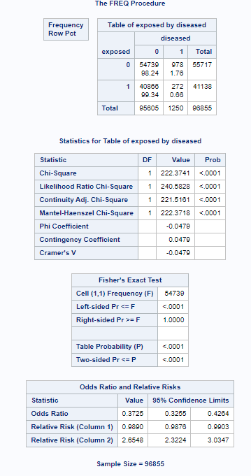

In conclusion the Relative Risk of ~0.37 meant for this sample that smoking lowered your chance of thyroid cancer to 0.37 which means that smoking could lower your chances of thyroid cancer compared to not smoking. SImilarly the Risk Difference showed that there are ~1.094 cases of disease per 100 persons in the unexposed (non-smoker) group versus the exposed (smoker / previous smoker) group. The Preventative Fraction showed that This means that there is ~62.2% of thyroid cancer reduction in the exposed group that can be attributed to smoking. Finally under the null hypothesis of no association for this data the p-value was calculated as under 0.001 meaning that we rejected the hypothesis that there is no relation between smoking and a reduction in cases of thyroid cancer.